Instruction for task2

Chuanjie ZANG

699382953

1. Code attached to 'file(project1 - task3).txt'
2. Input user
3. As the assignment, I fixed the number of guesses to 10, and to fulfill the requirement of the game that the user should not know what the words are, I entered the names of 10 fruits in advance as a random dictionary.And the program tells the user how many letters the word to guess this time contains.

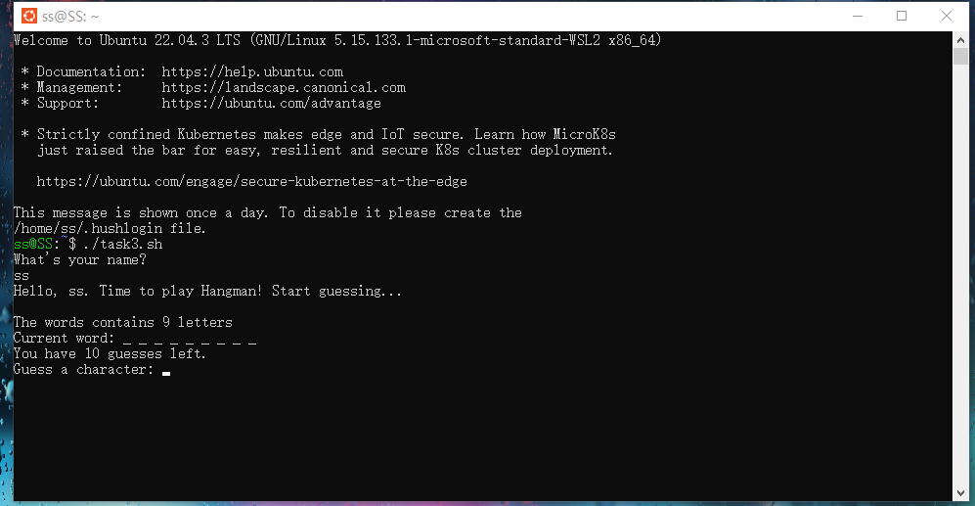

1. My code addresses several error-prone scenarios. 1) Words like "apple" contain repeated letters such as "p", but users are restricted from guessing letters that have been guessed previously. This restriction could make the game overly difficult and unrealistic. Because the game only requires users to guess which letters are included in the word, rather than their specific positions, my code addresses this issue: even if the word contains repeated letters, the code correctly determines when the user successfully guesses all the letters included in the word.

2) The program also prompts the user when the letter guessed by the user is a duplicate of a previously guessed letter and does not reduce the number of guesses.

3) When the number of guesses runs out, the program will correctly prompt the user. Here my program avoids the problem that the user makes a mistake in judging the number of guesses and the word when the last guess is correct.

